### 

### 

Q.1)**Program to check given number is even or odd:**

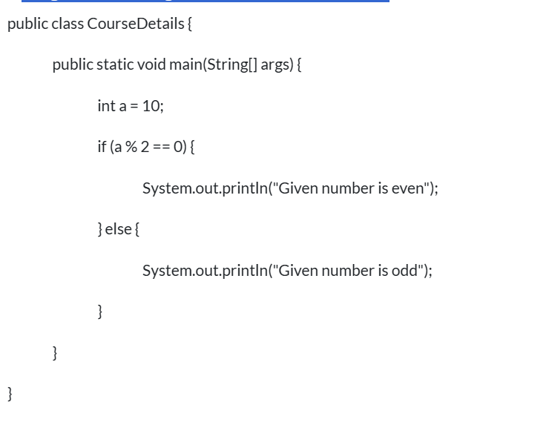

### Q.2)**.Reverse of the given number:**

### 

### 

### Q.3)**To check the given number is palindrome or not:**

### 

Q.4)**To check the given number is Armstrong number:**

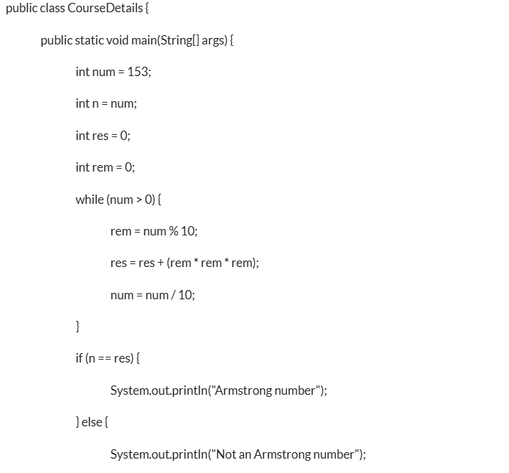

Q.5)**To find the sum of the digits in a given number:**

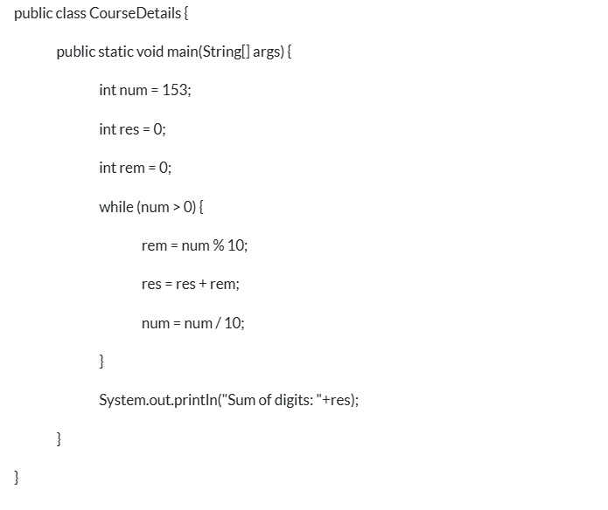

Q.6)**To find the product of the digits in a given number:**

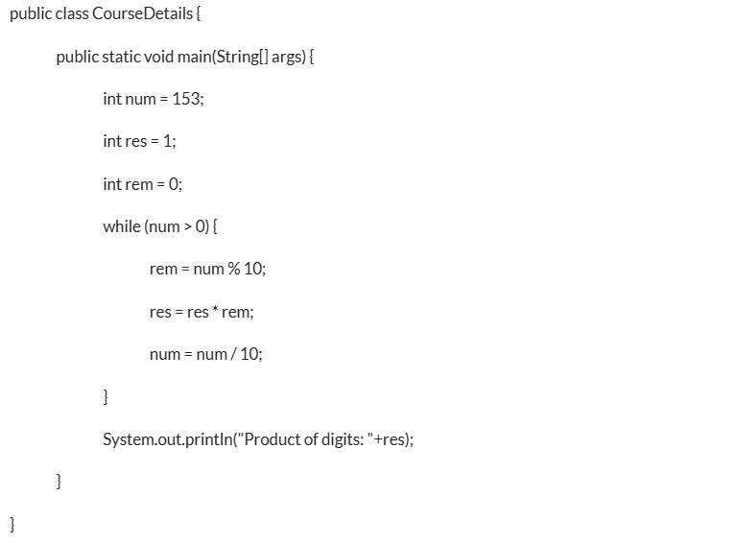

### Q.7)**To find the count of the digits in a given number:**

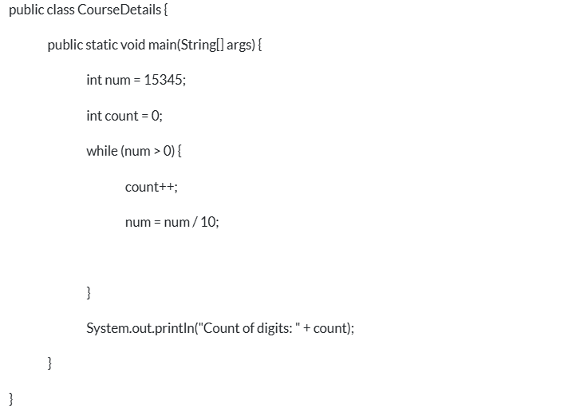

### Q.8)**12.Factorial of the given number:**

### 

### Q.9)**.Fibbonacci series for the given number:**

### 

### Q.10)**Find the reverse of the given string:**

### 

### 

### Q.11)**Check whether the given string is palindrome or not**

### 

### Q.12)**To find the reverse of each word:**

### 

Q.13)**To Change each word's first letter to upper case:**

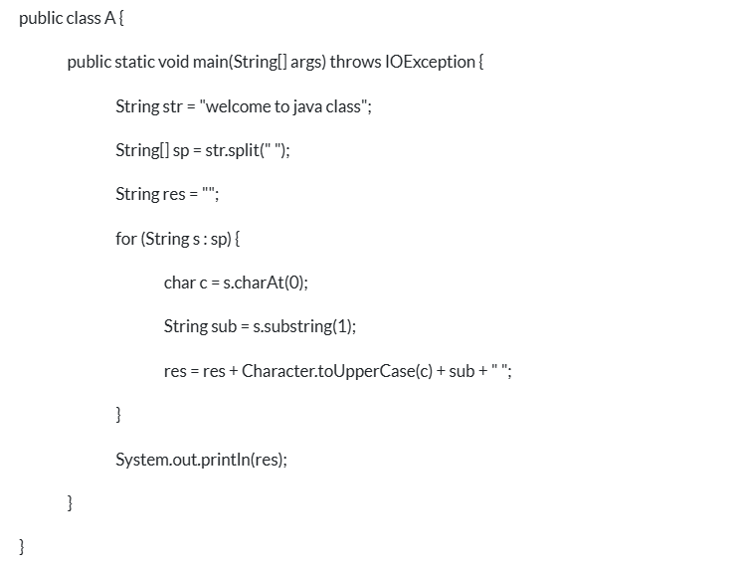

Q.14)**To remove character duplicates from String:**

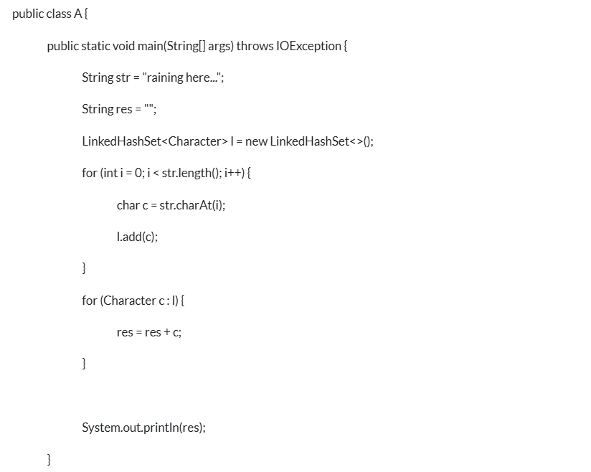

Q.15)T**o remove the duplicates and to sort elements from Array:**

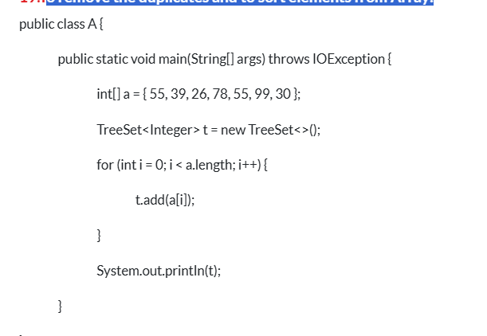

Q.16)**To sort numbers in ascending order:**

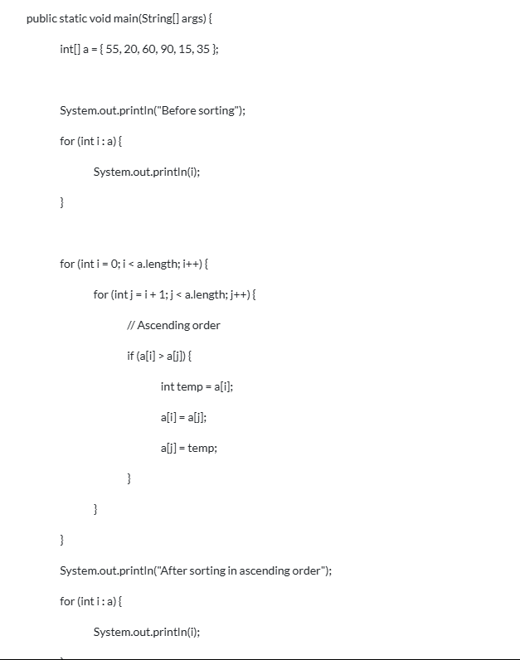

### Q.17)**To find count of each character in string(Count of duplicates of each character):**

### 

**Q.18) Write a method to return the odd numbers and their frequency from an integer array list passed as an input parameter.**

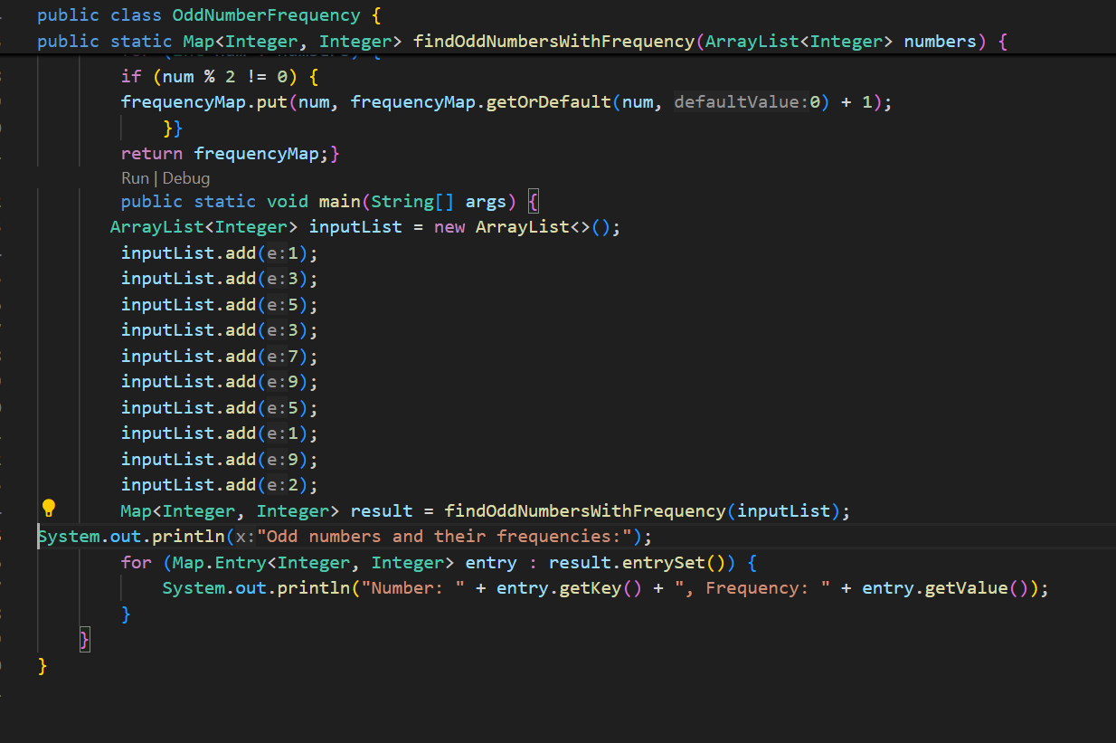

Q.19)**To find count of each word in string(Count of duplicates of each word):**

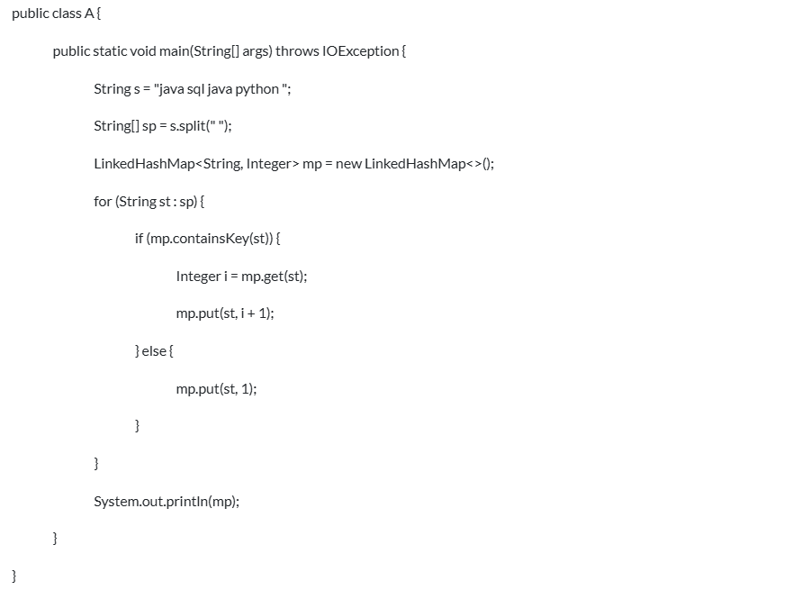

Q.20)**To find count of each character in string(Count of duplicates of each character) using normal for loop:**

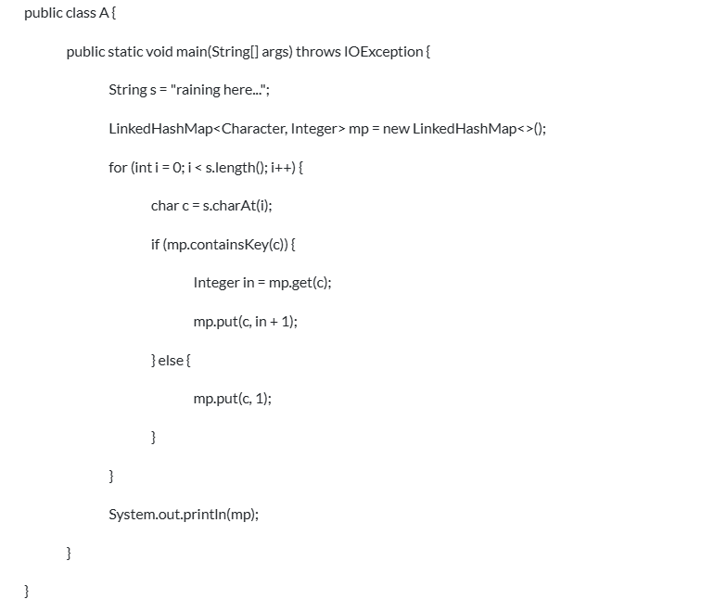

Q.21)**.To find the vowels and consonants in the given String:**

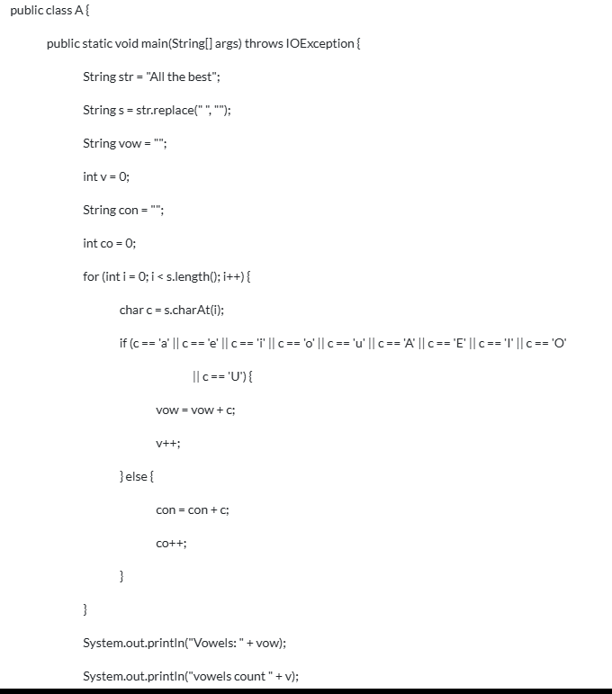

Q.22)**To check the given number is prime or not:**

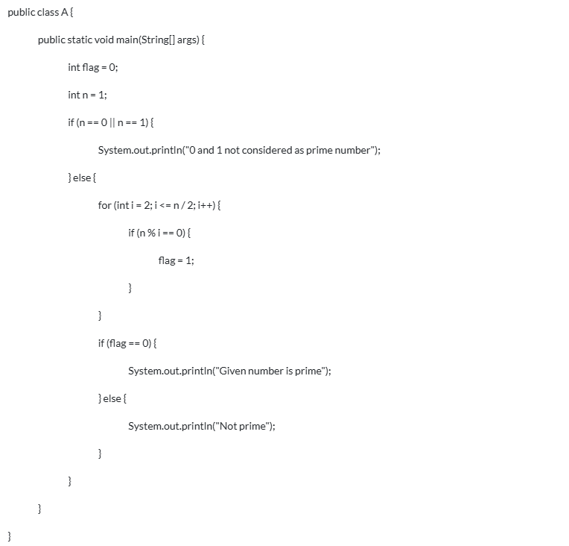

### Q.23)**Generate the given pattern:**

### *

### * *

### * * *

### 

Q.24)**.Generate the given pattern:**

1

2 2

3 3 3

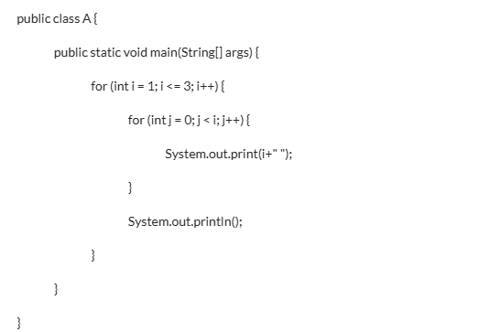

Q.25)**Generate the given pattern:**

1

1 2

1 2 3

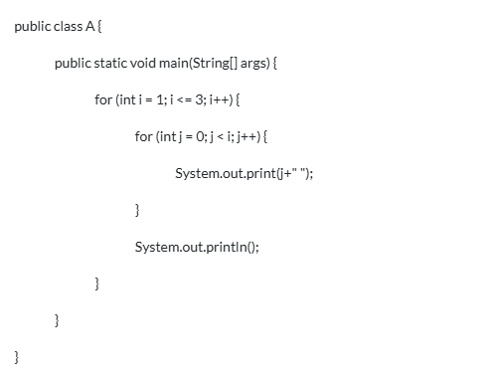

Q.26)**.Generate the given pattern:**

*

* *

* * *

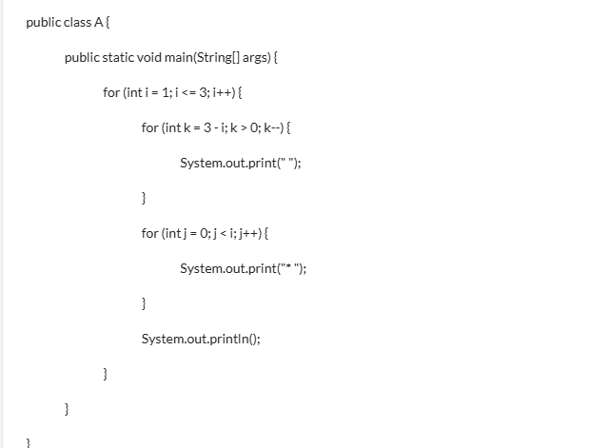

Q.27)**.Generate the given pattern:**

*

**

***

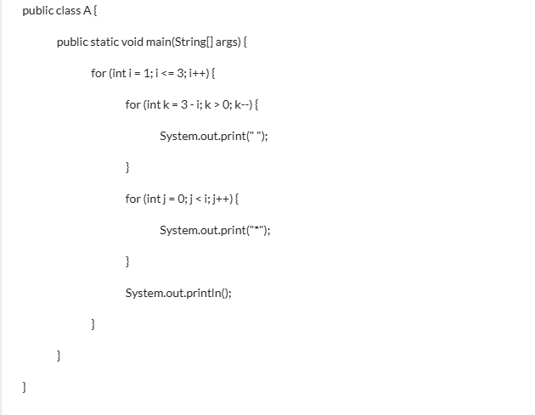

Q.28)Java Program to find Second Largest Number in an Array

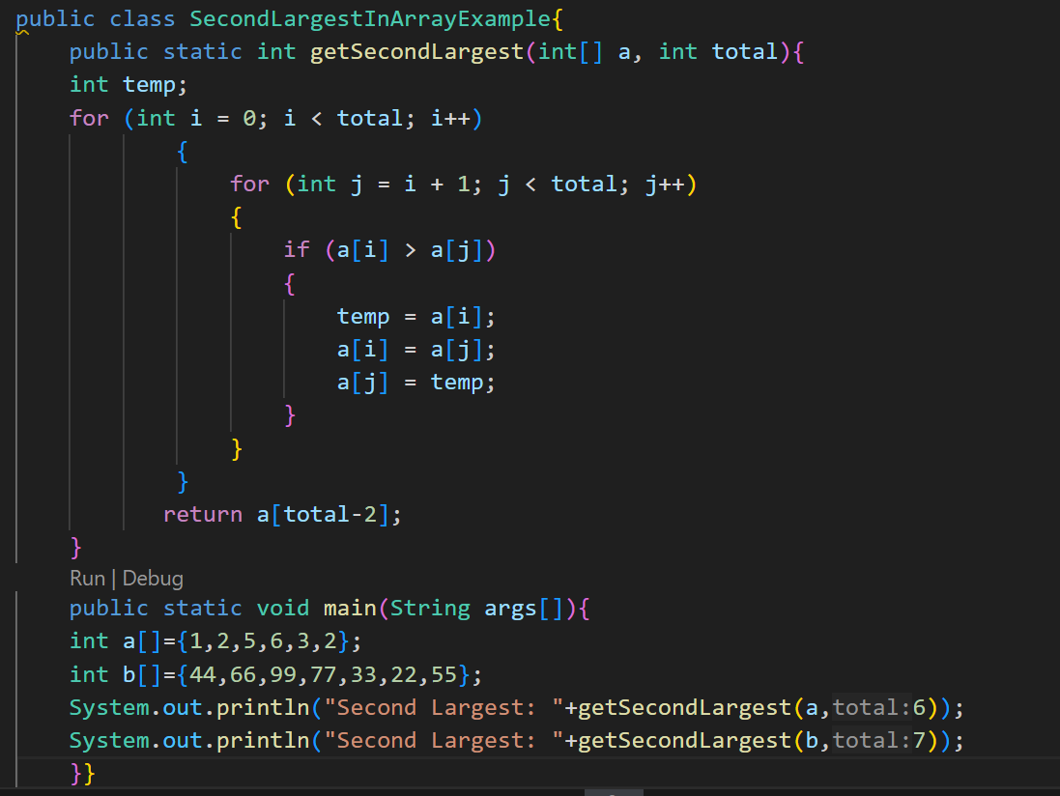

Q.29)Java Program to find the transpose of a given matrix

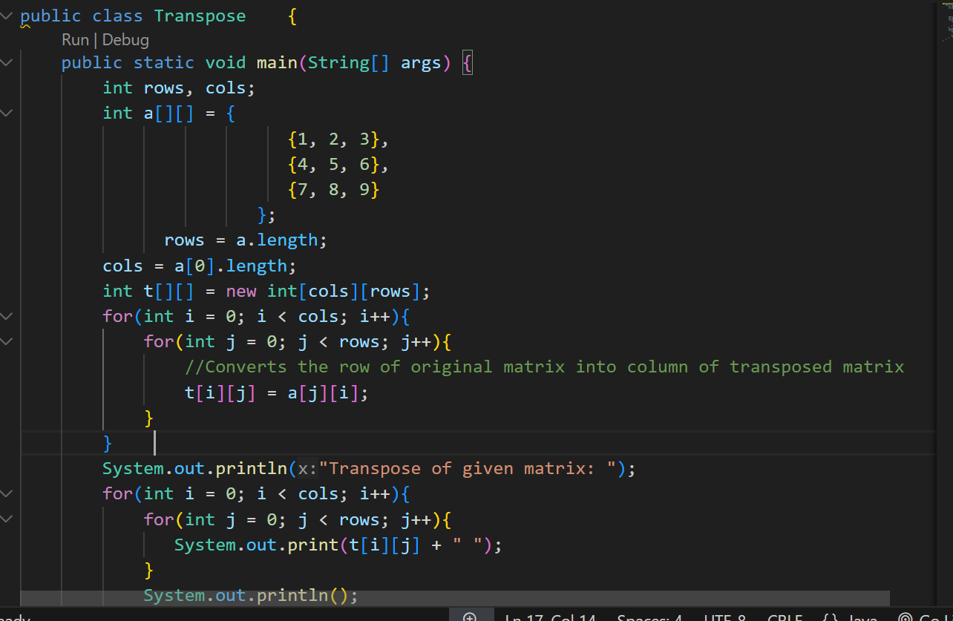

### Q.30) Write a Java program to check if the two strings are anagrams.

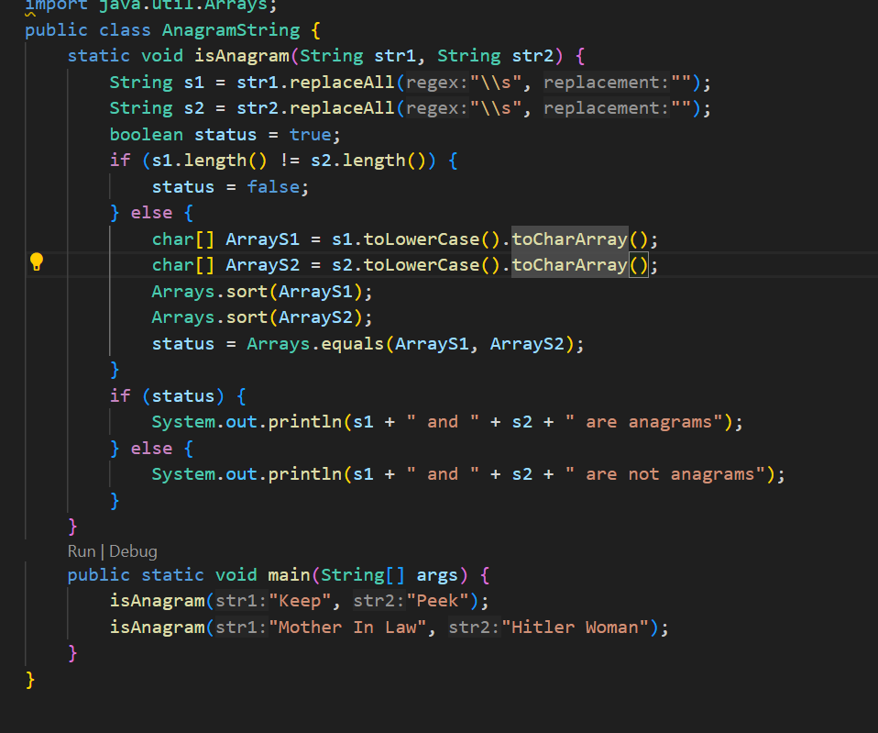

### Q.31) Write a Java program to create and throw custom

### 

### Q.32)Find the word count in a string using HashMap Collection.

### 

Q.33)Demonstrate the basic "divide by 0 exception" with the help of a Java

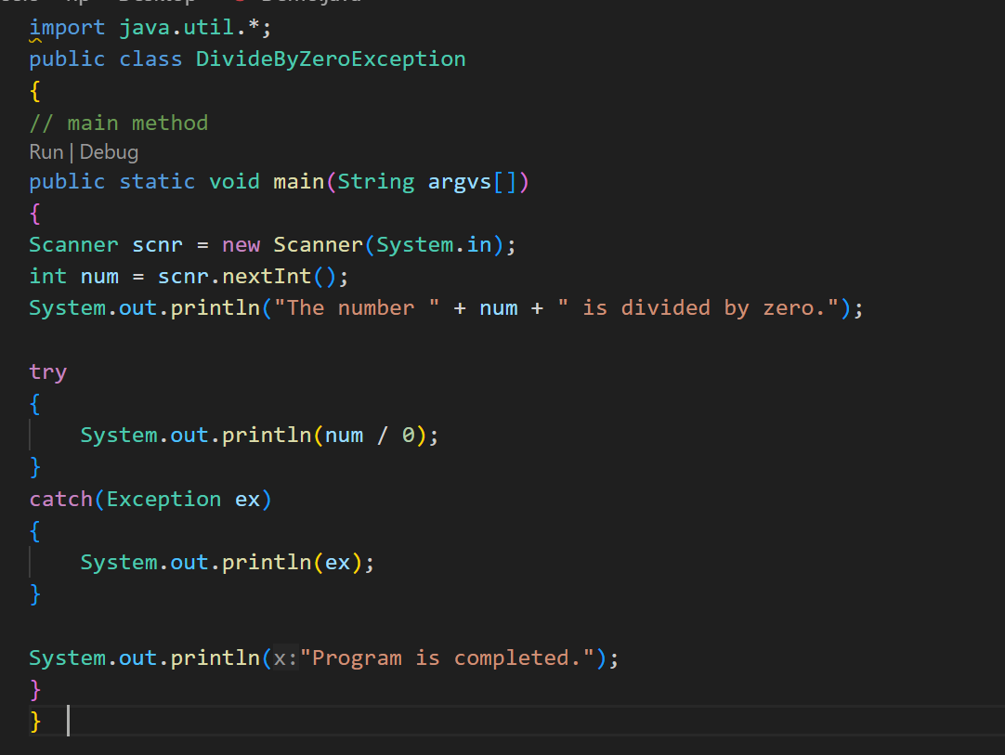

Q.34)How is an infinite loop declared in Java?

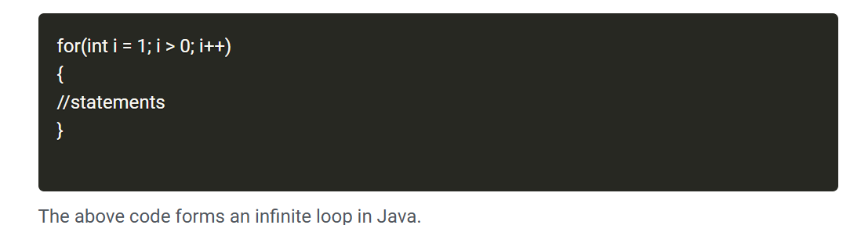

Q.35)What are the different ways of thread usage?

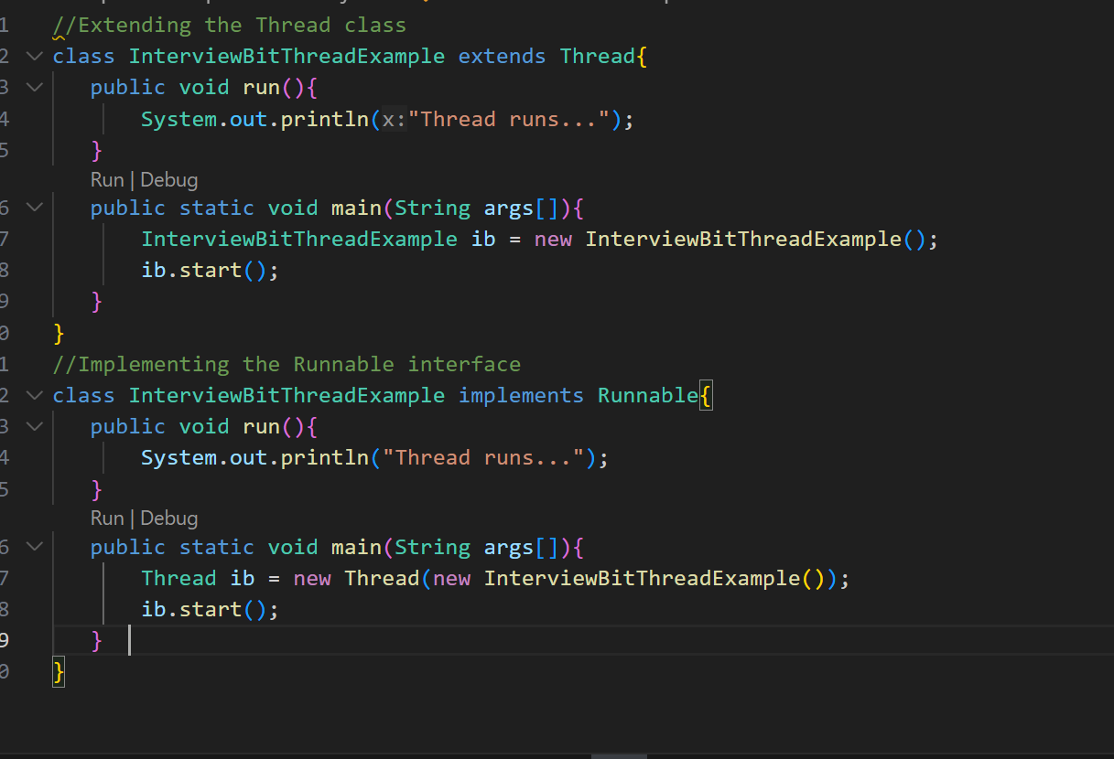

Q.36) [**How do you shuffle an array in Java**](https://www.digitalocean.com/community/tutorials/java-programming-interview-questions#20-how-do-you-shuffle-an-array-in-java)

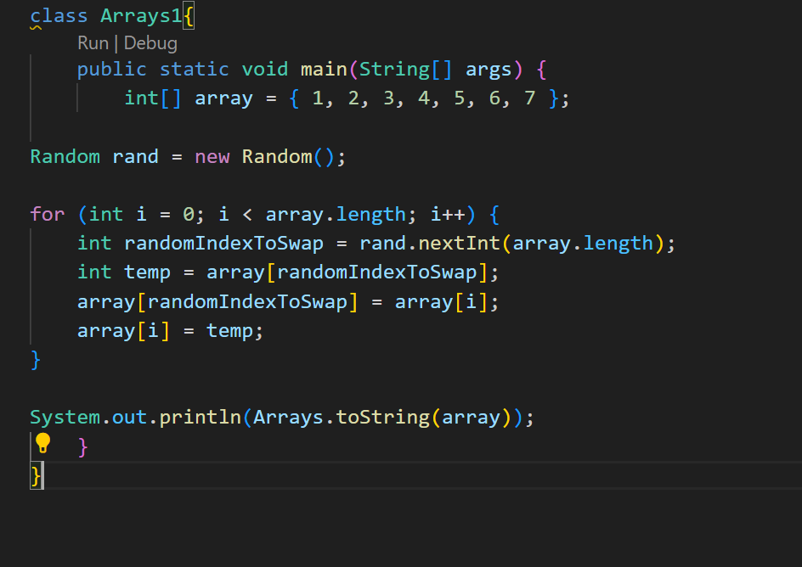

Q.37)[**How do you show a diamond problem with multiple inheritance in Java?**](https://www.digitalocean.com/community/tutorials/java-programming-interview-questions#29-how-do-you-show-a-diamond-problem-with-multiple-inheritance-in-java)

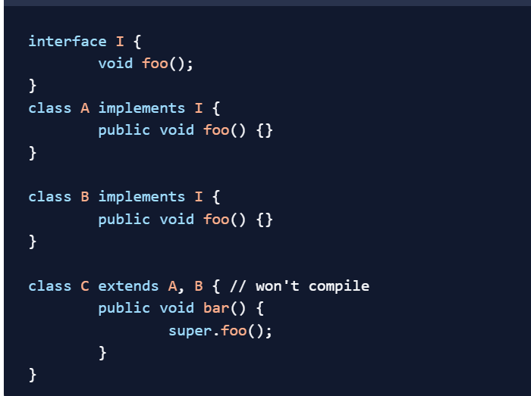

Q.38)Write a program that prints the numbers from 1 to 100. But for multiples of three, print “Fizz” instead of the number, and for the multiples of five, print “Buzz”. For numbers that are multiples of both three and five, print “FizzBuzz”.

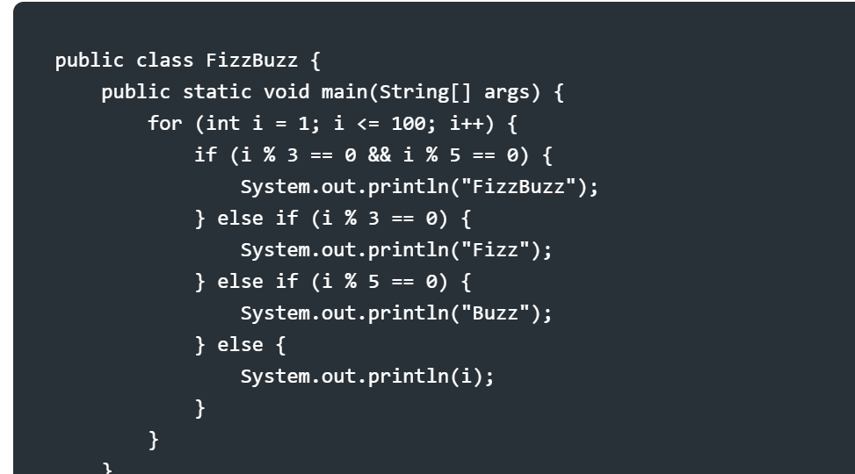

Q.39)To find the missing number in an array containing distinct numbers taken from 0 to n, you can utilize the concept of arithmetic progression and Gauss’s formula. Here’s a Java program to find the missing number:

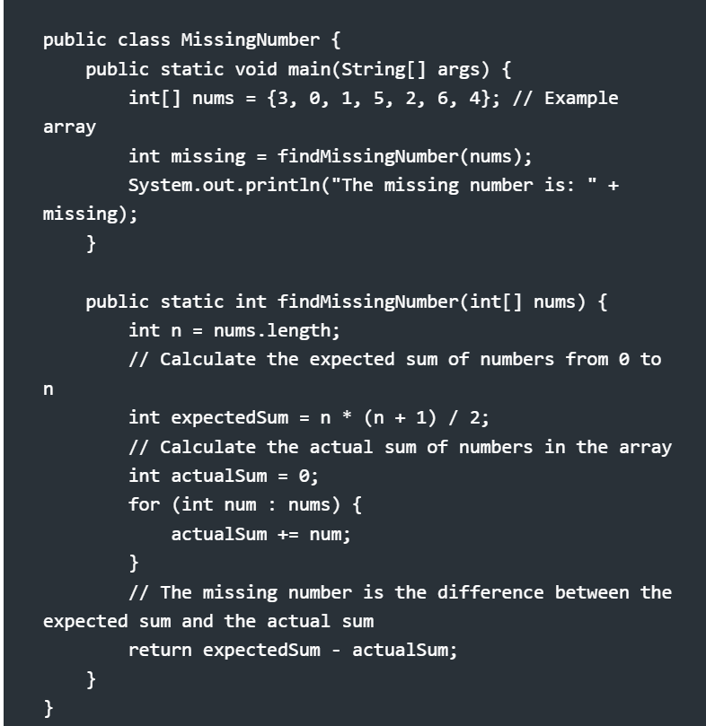

Q.40)Write a Java 8 program using a lambda expression to add two integers

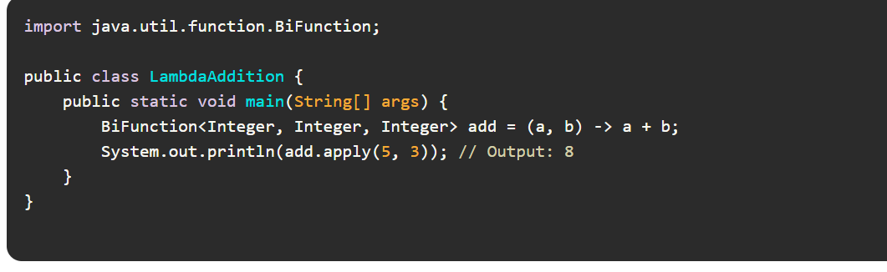

Q.41)**Write a Java 8 program to filter and print even numbers from a list.**

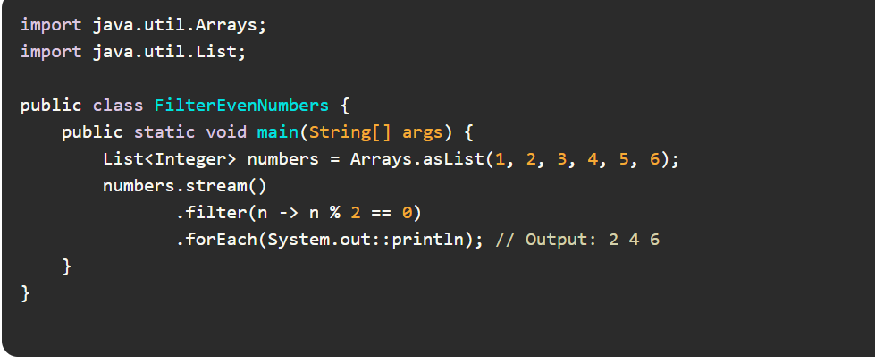

Q.42)**Write a Java 8 program to find and print the maximum value from a list**

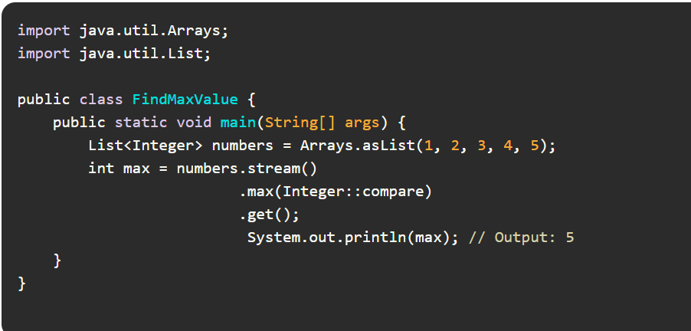

Q.43)**Write a Java 8 program to print distinct elements from a list of integers.**

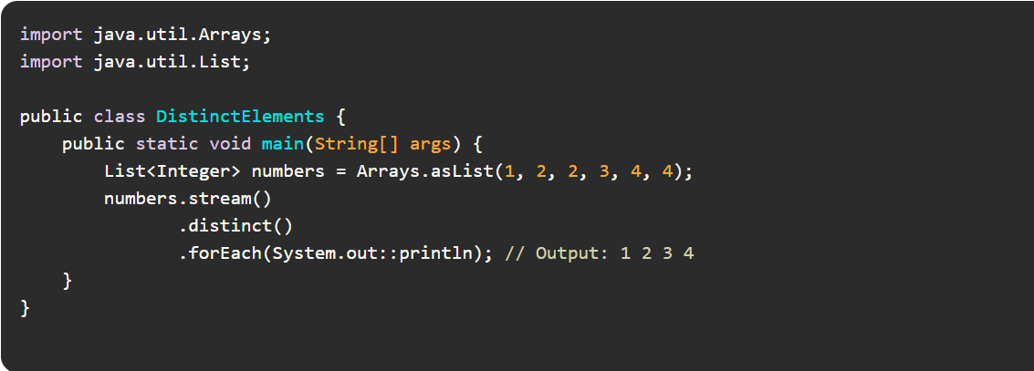

Q.44)**Write a Java 8 program to create a custom functional interface for addition**

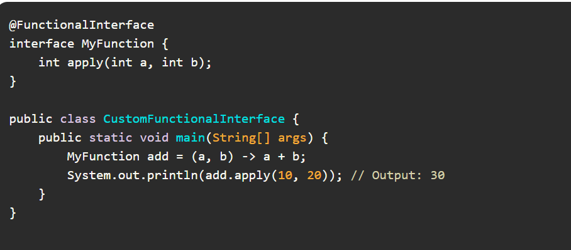

### **Q.45)Write a Java 8 program to check if any number in a list is even**

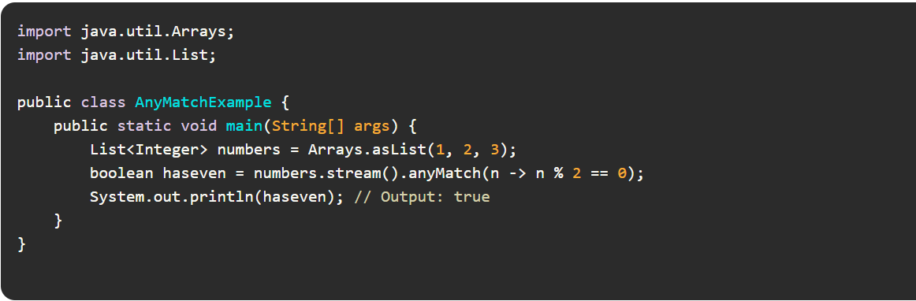

Q.46)Write a program to sort a list of strings in alphabetical order using Java Stream API

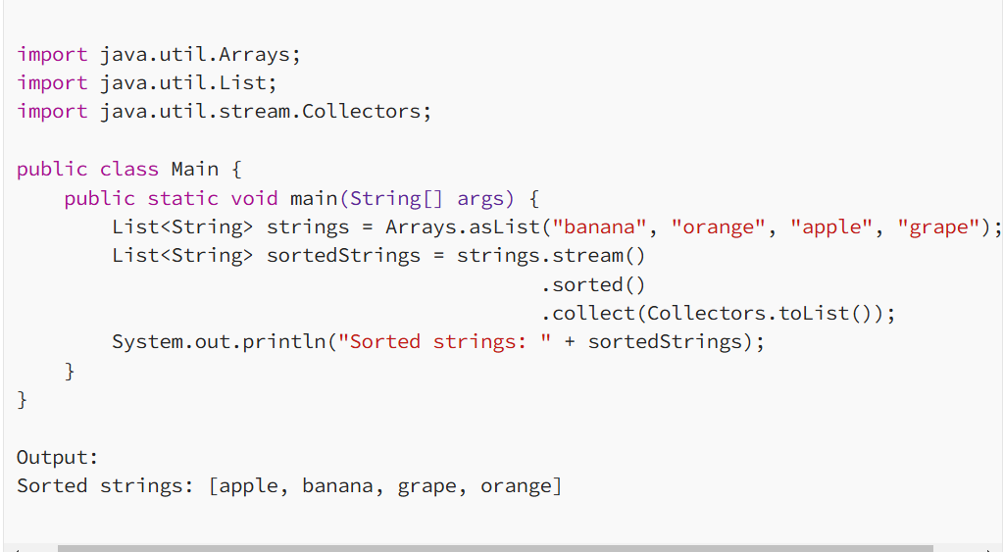

Q.47)Write a program to reverse a list of strings using Java Stream API.

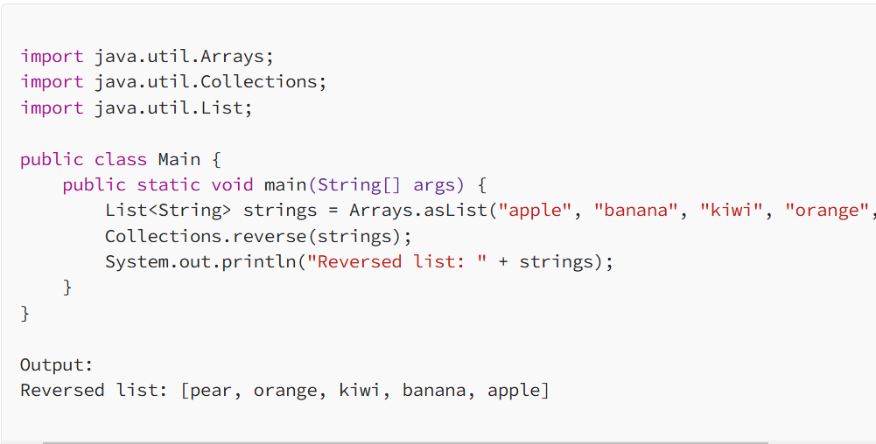

Q.48)Given a list of strings, write a program to count the number of strings containing a specific character ‘a’ using Java Stream API.

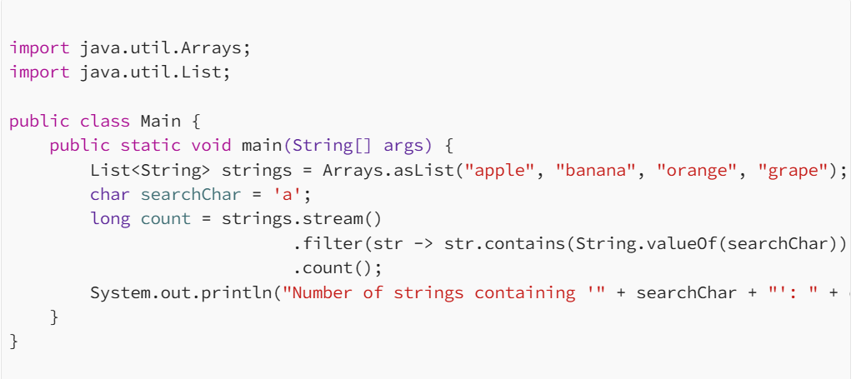

Q,49)Create an interface Payment with a method pay(double amount). Implement this interface in classes like CreditCardPayment and DebitCardPayment.

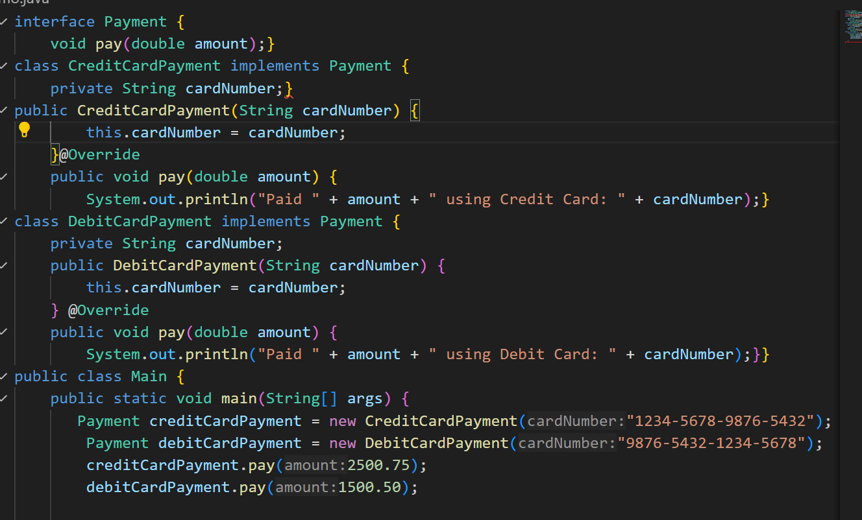

Q.50)**Implement a Binary Search Algorithm**

Input: Sorted array {1, 3, 5, 7, 9} and key 5

Output: Index 2

